Downtown
Tax Increment Financing (TIF)

Application

Department of Economic Development
101 South Broadway ∙ Salem, Illinois 62881
ecodev@salemil.us
(618) 548-2222 x16

City of Salem
Department of Economic Development
Tax Increment Financing

TABLE OF CONTENTS

TIF Overview ………………………………………………………....... 3
Application Requirements ……………………….......................... 4
Downtown TIF Boundary Map ………………………………………. 5
Downtown TIF Application …………………………………….……. 6-9

TAX INCREMENT FINANCING (TIF) PROGRAM OVERVIEW

The City of Salem may elect to provide financial assistance to local economic development projects, from infrastructure improvements to business expansions, by using new property taxes that result from the commercial investment and corresponding increase in property value. The state program that guides and encourages this local economic development activity is called municipal tax increment financing (TIF).
TIF is a tool that permits a municipality to participate in local project financing by using some or all of the new property taxes from a capital investment within a designated geographic district. The municipality has the option of using the “incremental" taxes to retire bonds it has issued for the project, compensate a developer or business for development project costs, or fund eligible municipal economic development activities.

Eligible Redevelopment costs for TIF funding

TIF funds may be used for costs that will permit previously developed properties to compete with vacant land at the edge of the municipal area. State legislation authorizes that TIF funds may be used for:

• Property acquisition
• Rehabilitation or renovation of existing public or private buildings
• Construction of public works or improvements
• Job retraining programs
• Relocation
• Financing costs including interest assistance
• Studies, surveys and plans
• Professional services such as architectural, engineering, legal, property marketing and financial planning
• Demolition and site preparation

Ineligible Uses for TIF Revenues

Ineligible project costs include those for facilities, buildings or portions of buildings used predominantly for the general conduct of government, or for public recreational purposes. Examples include city halls and other headquarters of government where the governing body meets regularly, courthouses, jails, police stations and other state and local government office buildings, recreation centers, athletic fields and swimming pools.

To Be Considered an Eligible TIF Project:

- The creation and retention of jobs and broadening of the tax base, in considering project costs that are not clearly addressed in statute. Project costs should be contained within the TIF districts.

- Employers who are applicants for TIF are required to disclose the public purpose and project uses supported by the incentive, along with goals for the number, type and wage levels of jobs that will be created or retained.

- Downtown TIF funds are not to exceed $10,000, distributed as a 50% matching fund. A W-9 is required before any funds can be released by the City of Salem.

To apply:
Anyone wishing to use municipal tax increment financing to fund development programs must submit to the Office of Economic Development (OED) the completed application and any additional information the OED may request.

Department of Economic Development
Tabitha Meador, Director
101 South Broadway ∙ Salem, Illinois 62881
ecodev@salemil.us
(618) 548-2222 x16

Downtown Salem TIF Map
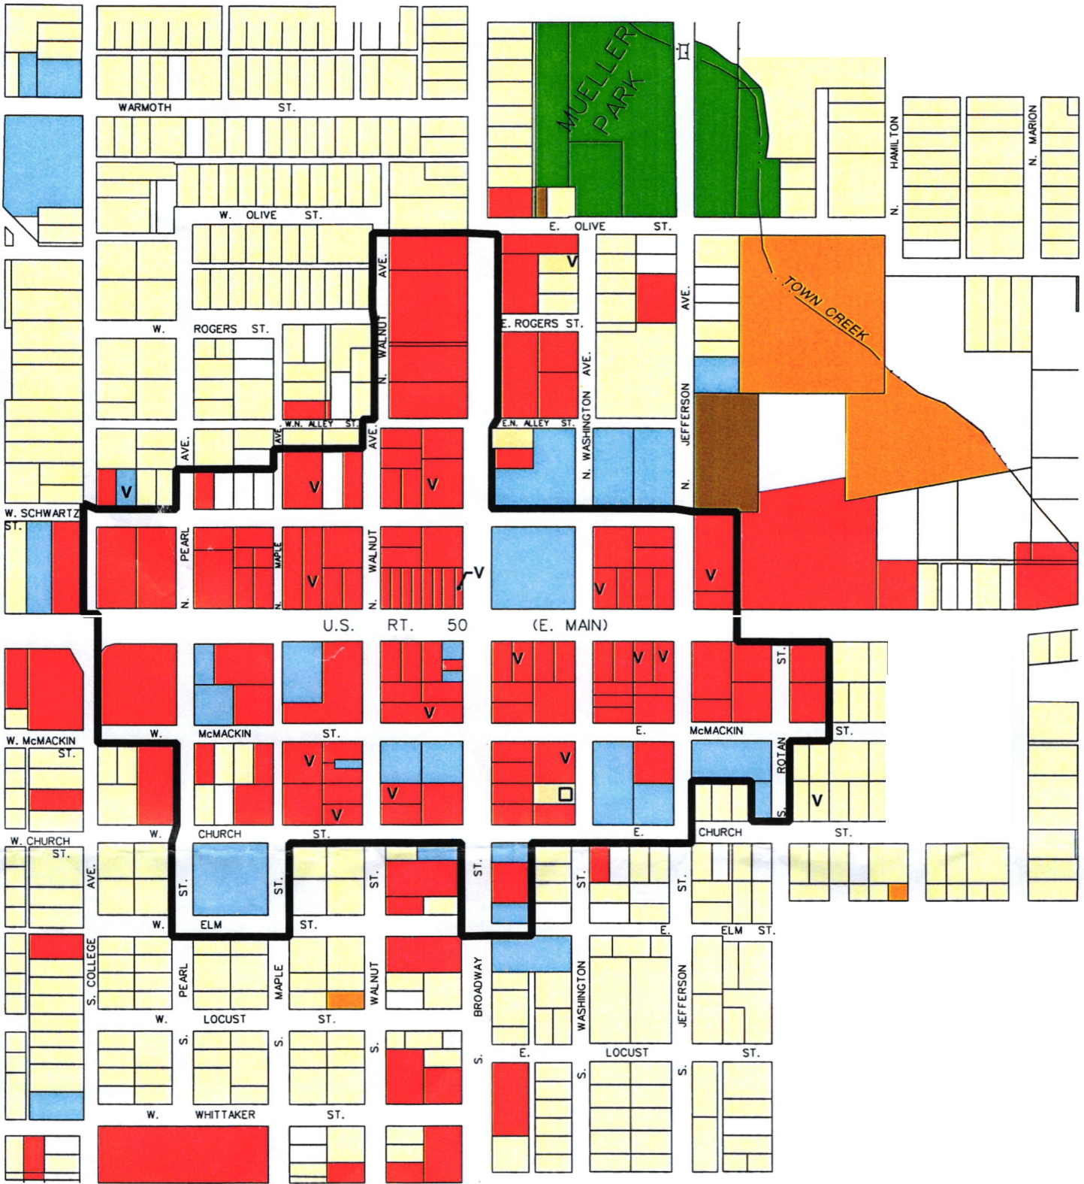
CITY OF SALEM TAX INCREMENT FINANCING APPLICATION
A. General Information

1. Business Name:

2. Address:
3. Telephone: 4. Fax: 5. Email: Email:Ejoshjosh@securityalarm.comjosh@securityalarm.comjosh@securityalarm.com
6. Business Contact Person:
7. Principal Place of Business:
8. Company Structure (e.g. corporation, sub-chapter, etc.):
9. Place of Incorporation:
10. Names of Officers:
11. Principal Owner(s) Name and % Ownership:
12. Address:

B. Disclosure

Check the public purpose that will be met by the business using this incentive (any that apply):
- job creation | - job retention | - capital investment
- training investment | - tax base improvement | - public facilities improvement
- façade improvement | - new business construction | - relocation/expansion
- retail attraction | - other (list):
Has the applicant received previous TIF assistance: Yes No

C. Description of Project
(Include ownership, proposed tenants, proposed benefits to the City, products and services created, new tax base, etc.)

D. Sources and Uses of Funds

 | Owner Equity | Bank | TIF | Other
Land  Acquisition | $ | $ | $ | $
Building  Acquisition | $ | $ | $ | $
Facade  Improvements | $ | $ | $ | $
Architectural | $ | $ | $ | $
Building  Rehabilitation | $ | $ | $ | $
Equipment/ Fixtures | $ | $ | $ | $
Furnishings | $ | $ | $ | $
Emergency  Repairs | $ | $ | $ | $
ADA/  Life Safety | $ | $ | $ | $
Building Code/ Electrical | $ | $ | $ | $
TOTAL | $ | $ | $ | $

E. Narrative explaining why the project could not be carried out without TIF assistance:

F. Collateral Description
List the following for collateral that will be offered for security for the City TIF Loan

G. Employment Goal
List the company’s goals for the number, type, and wage levels of jobs to be created or retained as part of the TIF development project (please attach narrative page).

A. Job Creation Goals
Occupational Cluster* | Full-time  Create/Retain | Part-time  Create/Retain | Wage  Level | Unions
1. Executive, Professional & Technical |  |  | $
2. Administrative Support, including Clerical |  |  | $
3. Sales & Service |  |  | $
4. General Labor |  |  | $
5. Maintenance, Construction, Production, & Transportation |  |  | $

Additional Required Documents:
H. Provide the latest 3 years of income taxes

I. Provide receipt of previous and current year’s sales tax payments

J. Provide proof of insurance on the property
The undersigned has applied for the loan/grant described in the application and the proceeds of said loan/grant will be used in connection with the project described herein. The Applicant agrees to abide by all City of Salem, Illinois TIF Redevelopment Program Guidelines.
The Applicant agrees to furnish information listed as application attachments and any additional information to the City as needed to review and consider this request.
The Applicant does hereby consent and agree that the City of Salem may conduct a credit bureau report and/or criminal background check.

Applicant's Signature

Applicant’s Printed Name

Date

For Office of Economic Development Use Only:

Date Application Received: _____________________________
Staff Signature:

Notes: _______________________________________________________________ _______________________________________________________________________________________________________________________________________________________________________________________________________________

